McGovern Chiropractic Daily Spinal Warm-ups

These exercises promote healing and the normal function and motion of your spinal discs, muscles, and ligaments. When done consistently, they prevent disc and spinal decay, break up scar tissue and reduce inflammation. Perform them first thing in the morning and right before going to bed in the evening. Also, taking time to do these throughout the day will help to ensure proper healing and spinal health throughout your life. Ten repetitions to each side are suggested with each.
Flexion and Extension:
- In same upright position as above, rest your hands on your knees and curl your spine forward beginning with your chin toward your chest and then your chest toward your thighs.
- Smoothly reverse the motion and continue by dropping your head back to look up at the ceiling. Think about moving every bone in your spine. When extending backward, you can press gently on your thighs to increase your joint and disc flexibility.
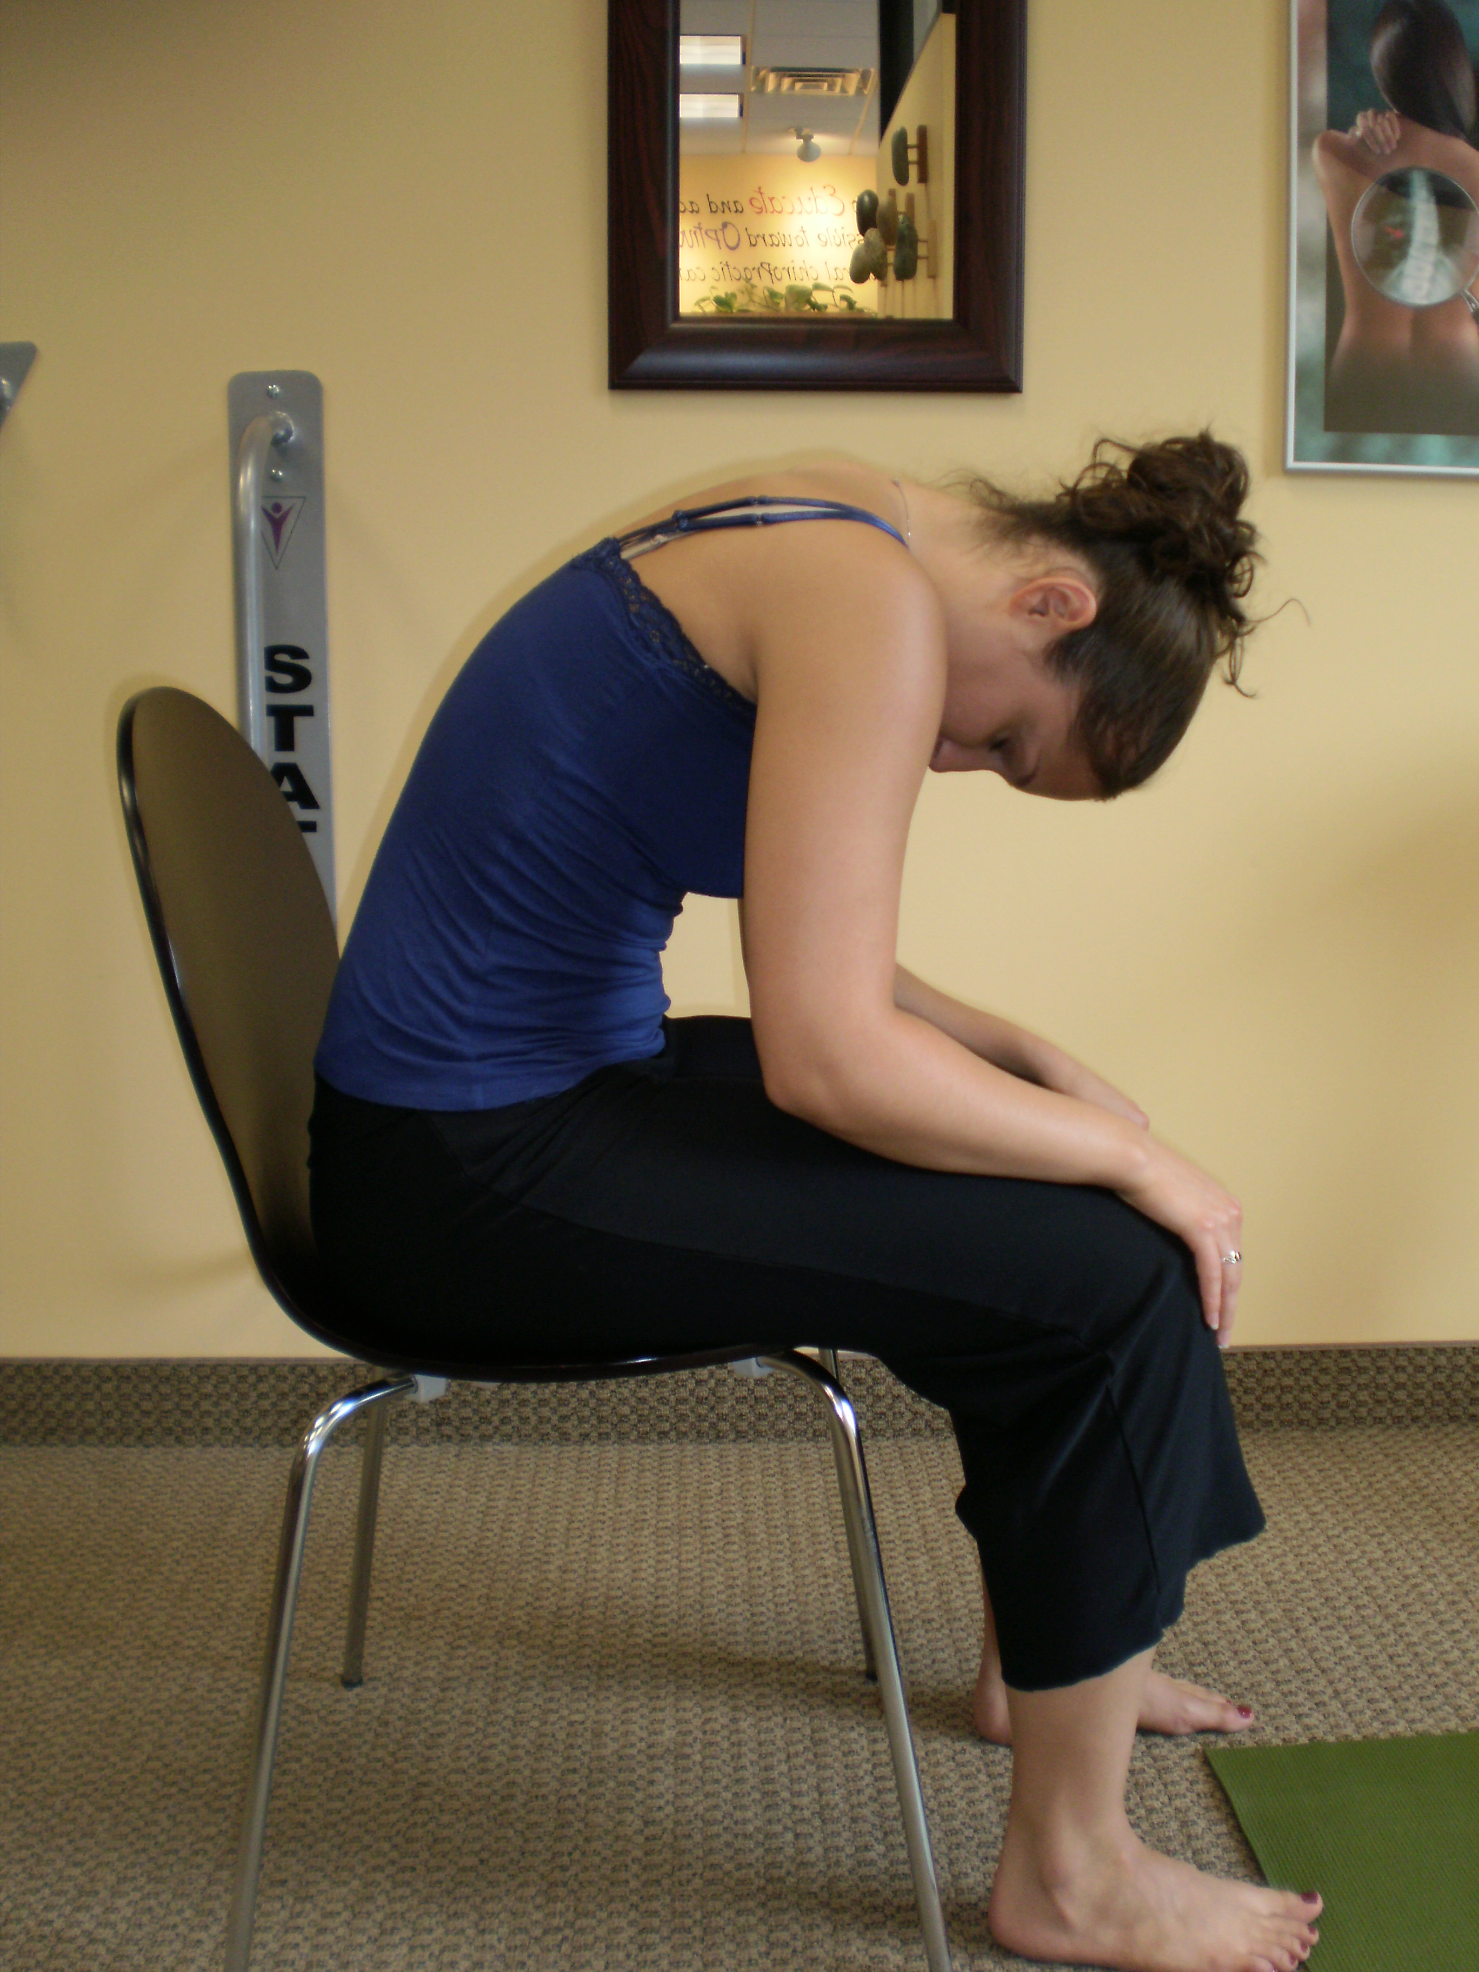
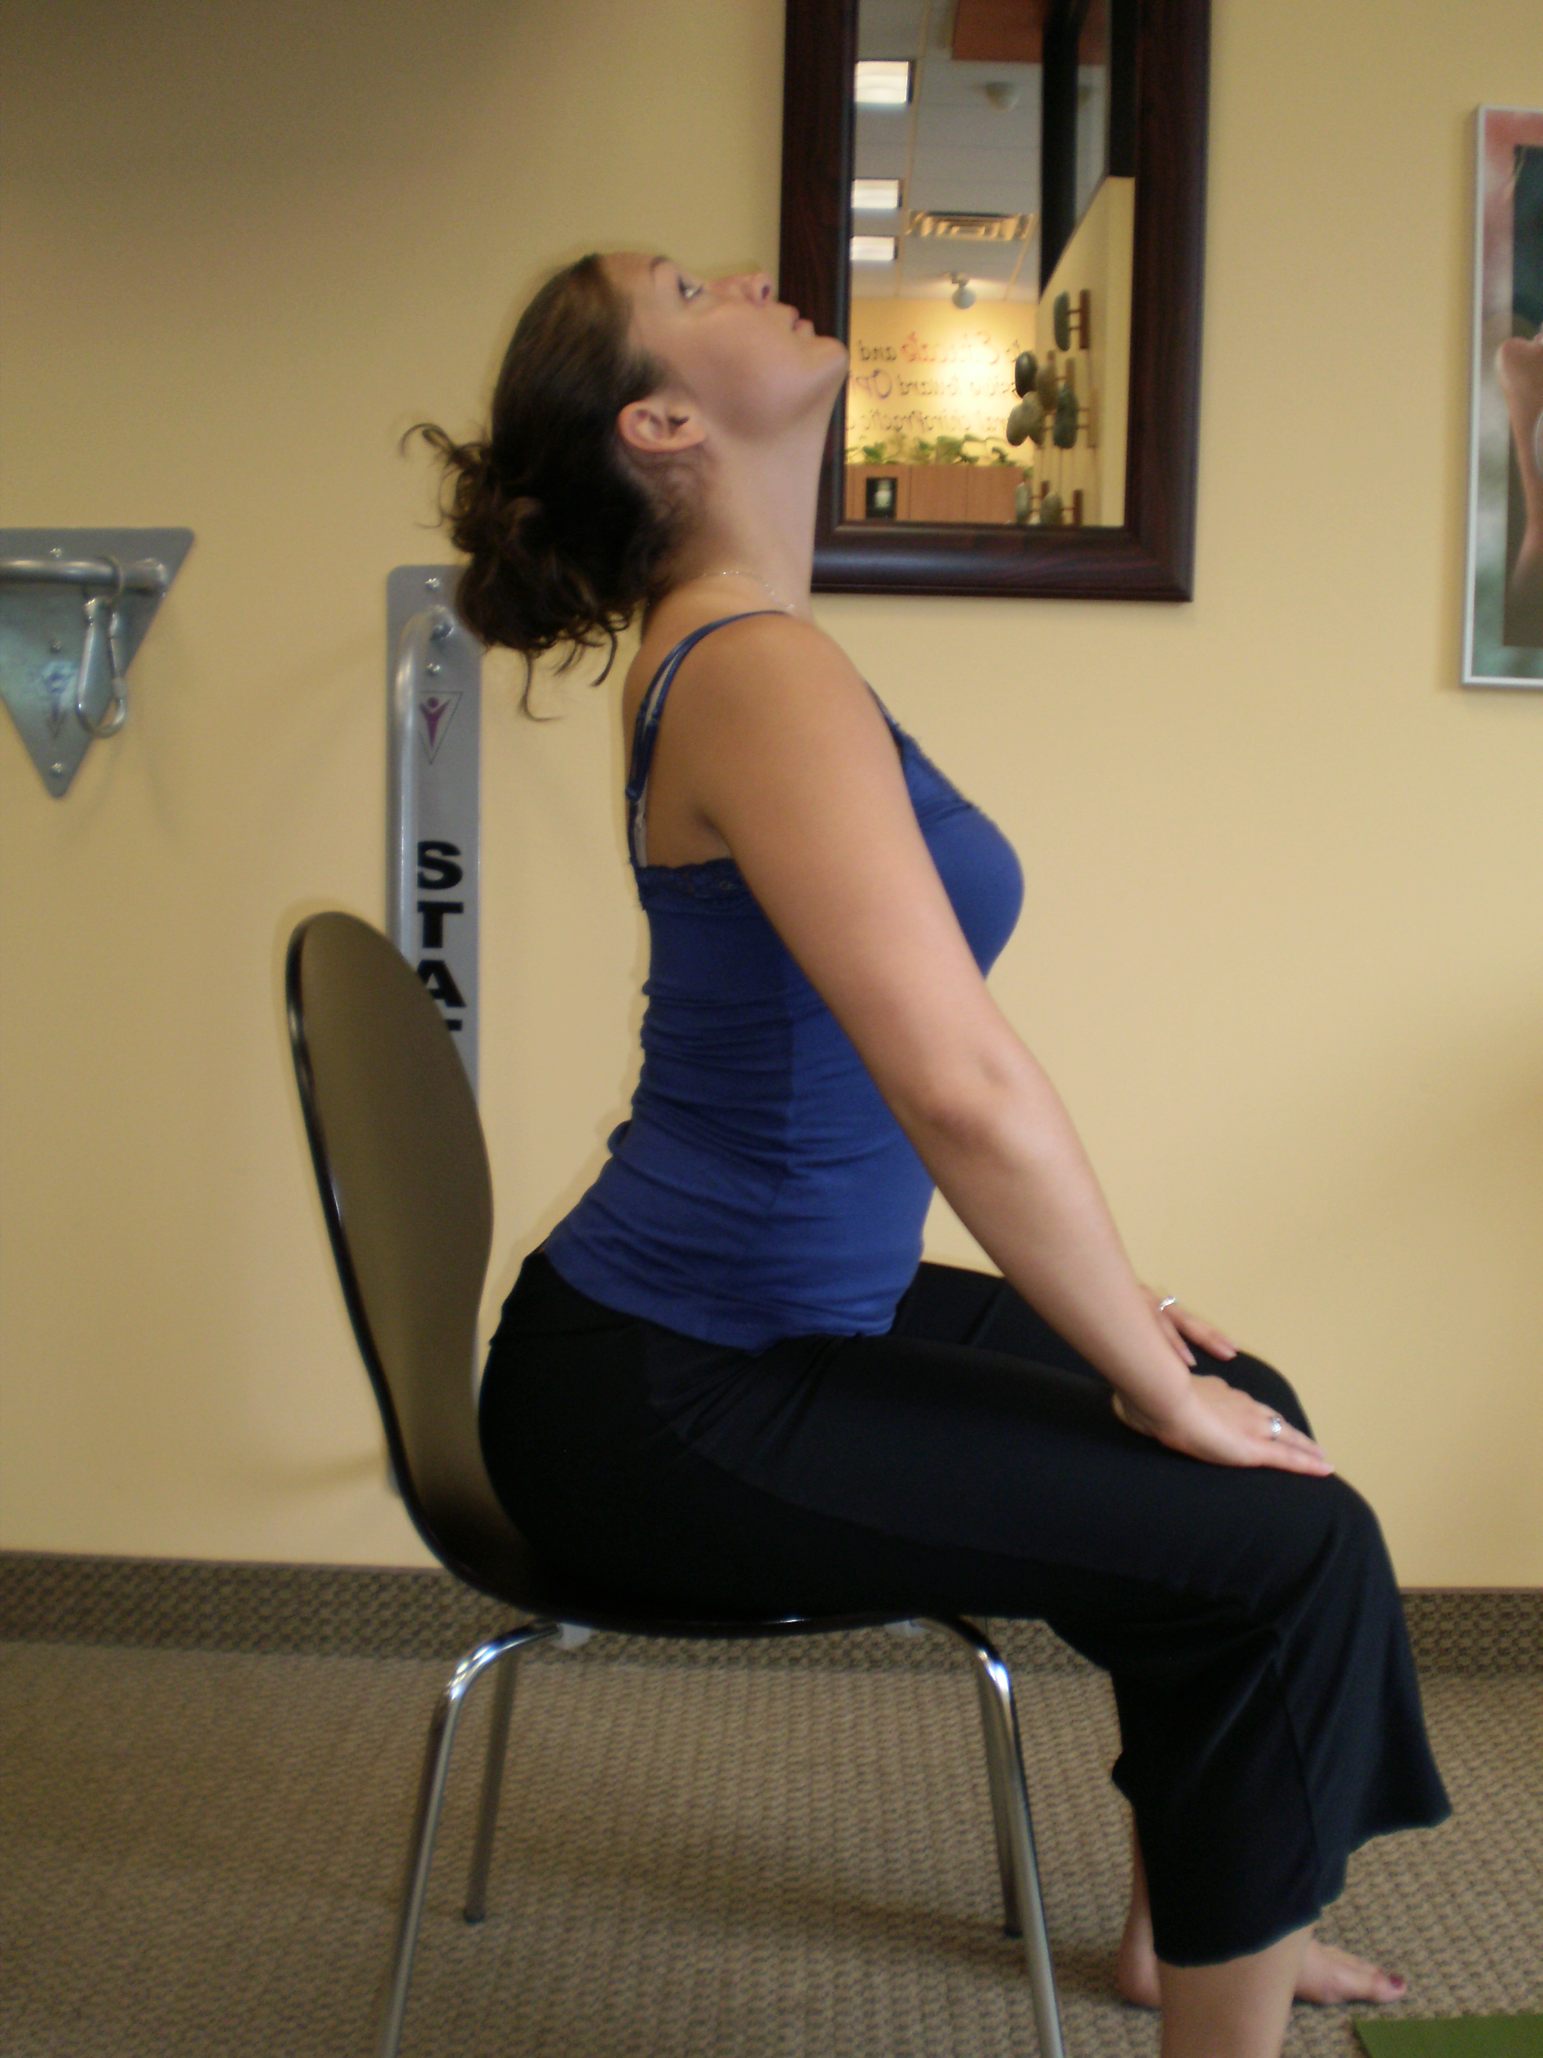

Spinal Rotation:
- Sitting upright, with feet on floor, slightly arch lower back and raise your arms to shoulder level. Interlace fingers and point elbows out to each side.
- Slowly turn your entire spine as far as you comfortably can to each side making sure to turn your head fully in each direction. It helps if you try to watch your elbows as you turn each way.
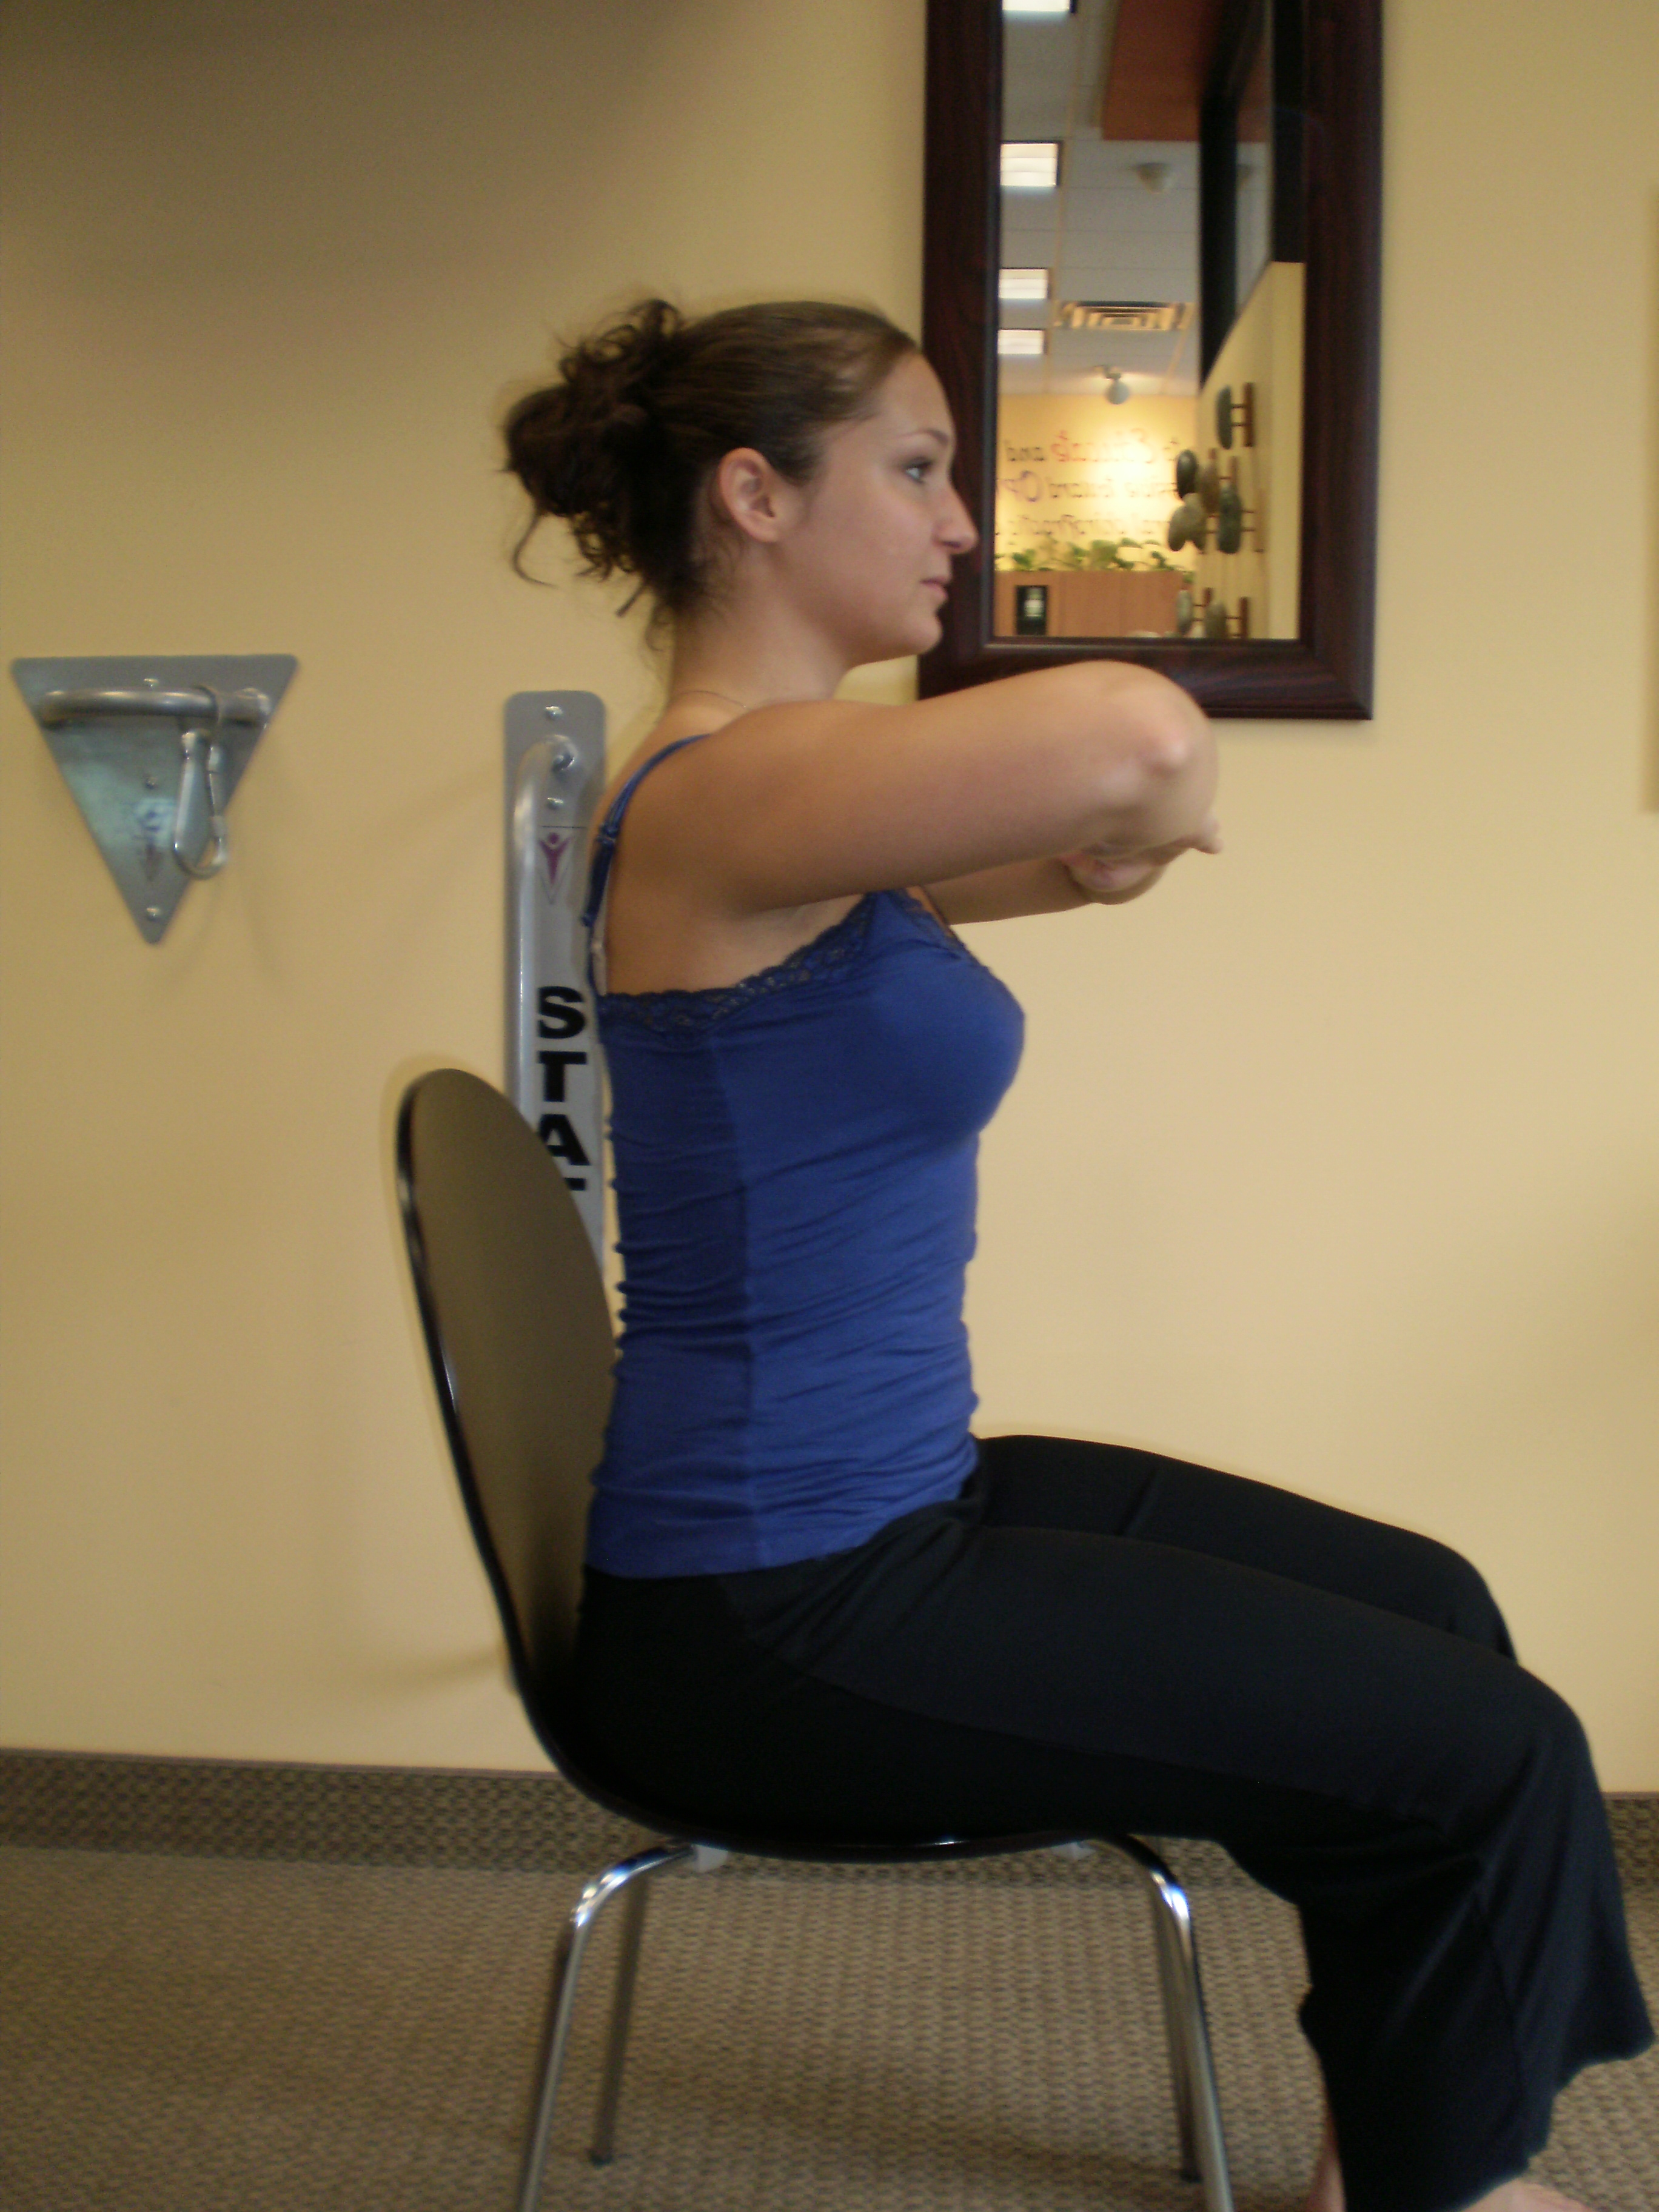
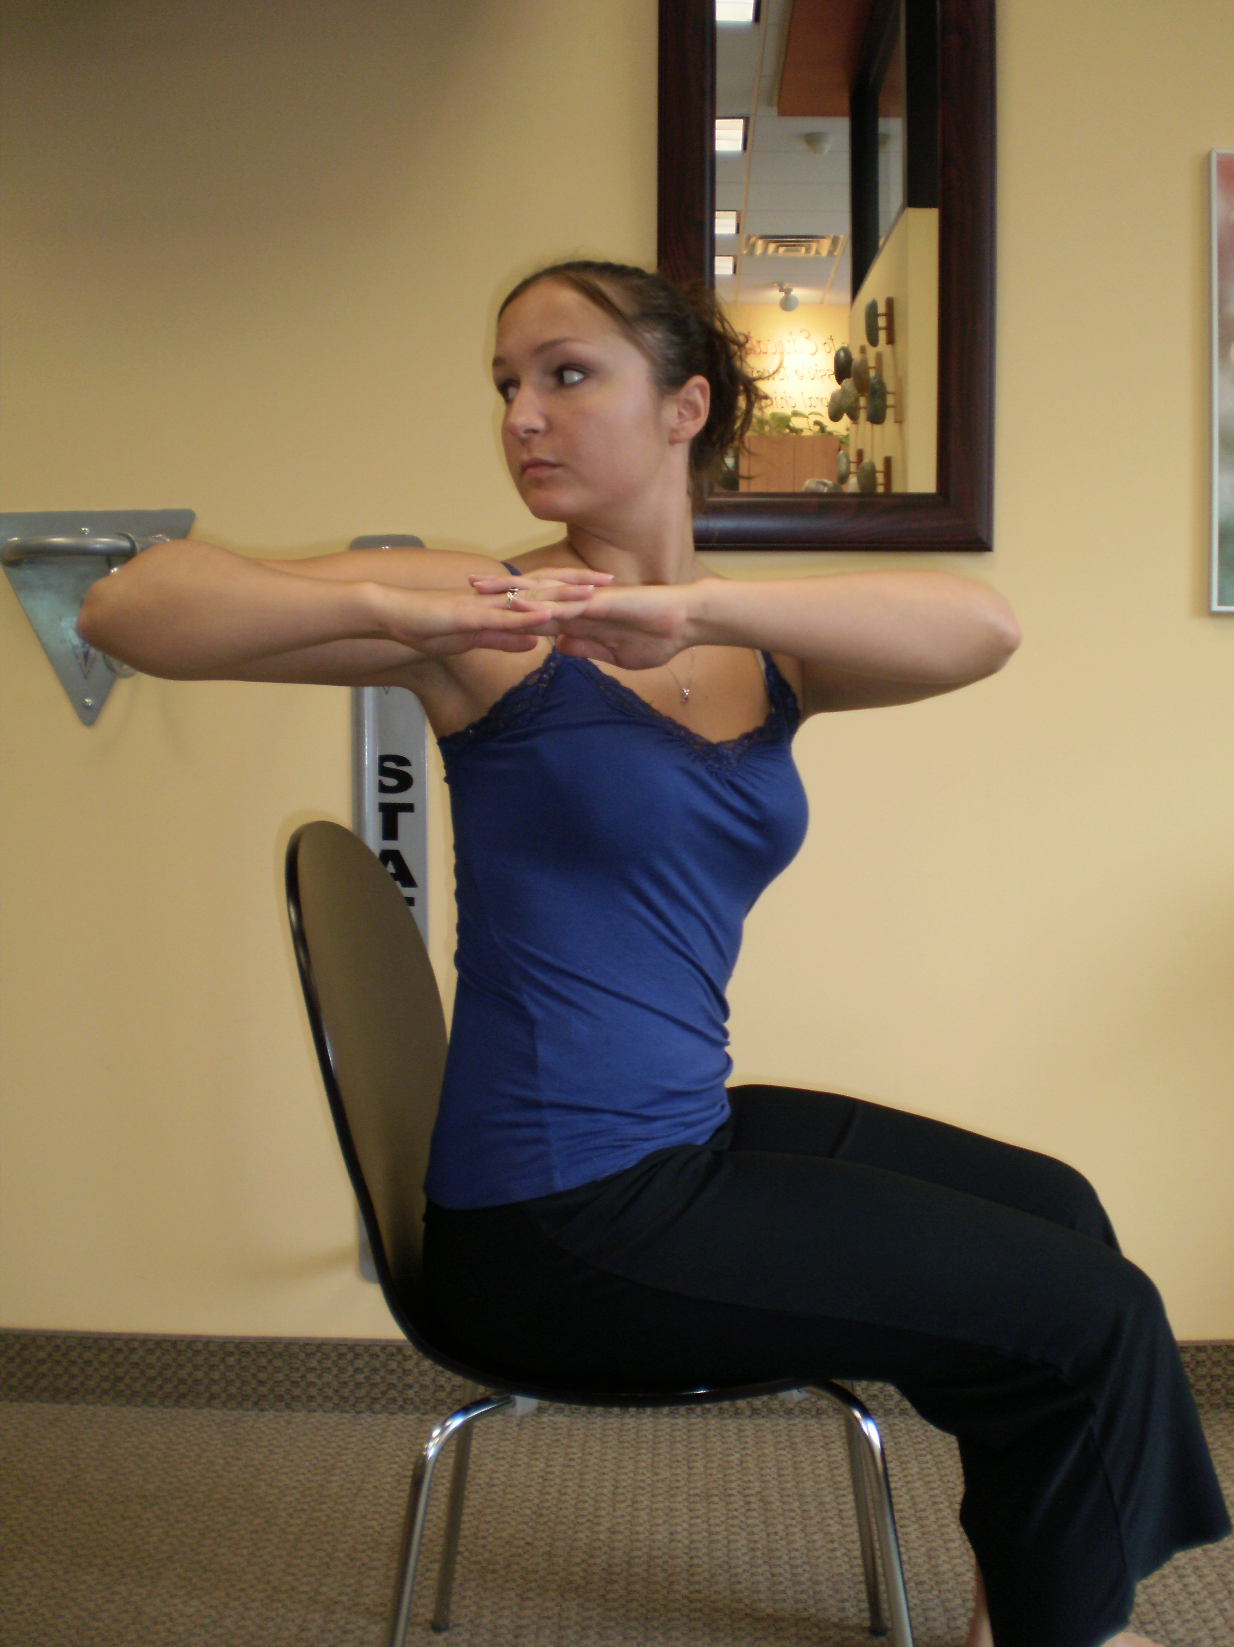

Left and Right Lateral Flexion:
- From an upright seated position, begin by bringing your left ear toward your shoulder and then continue to curve your spine to the left. See how far you can reach while remembering to bend sideways rather than forward.
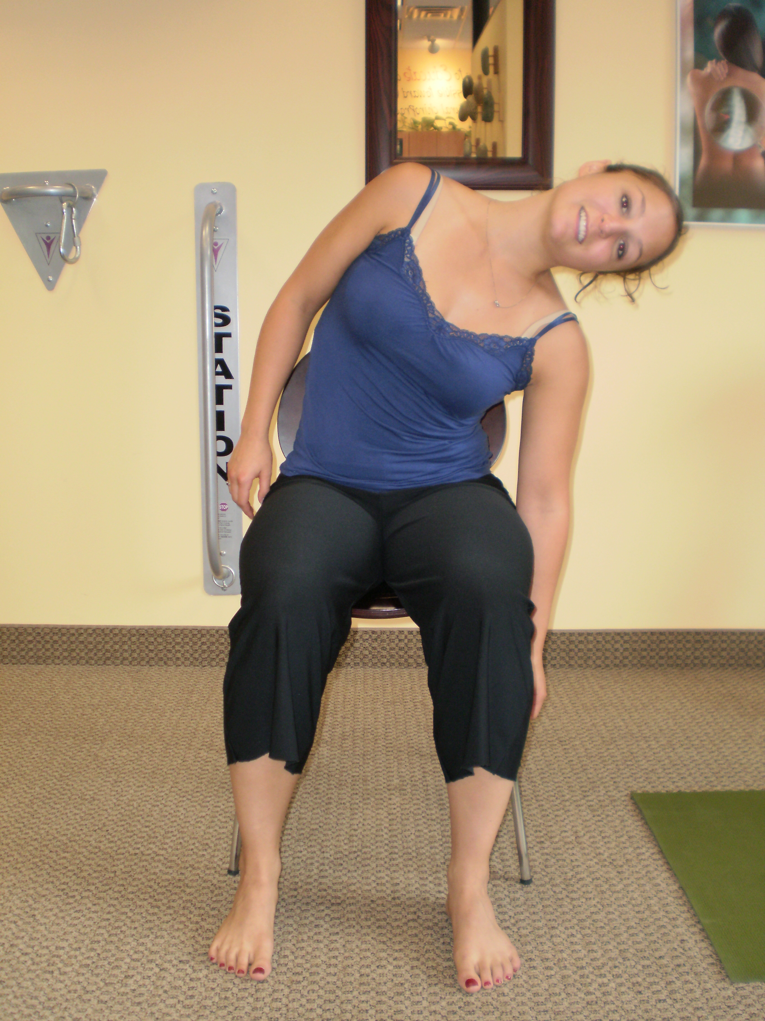
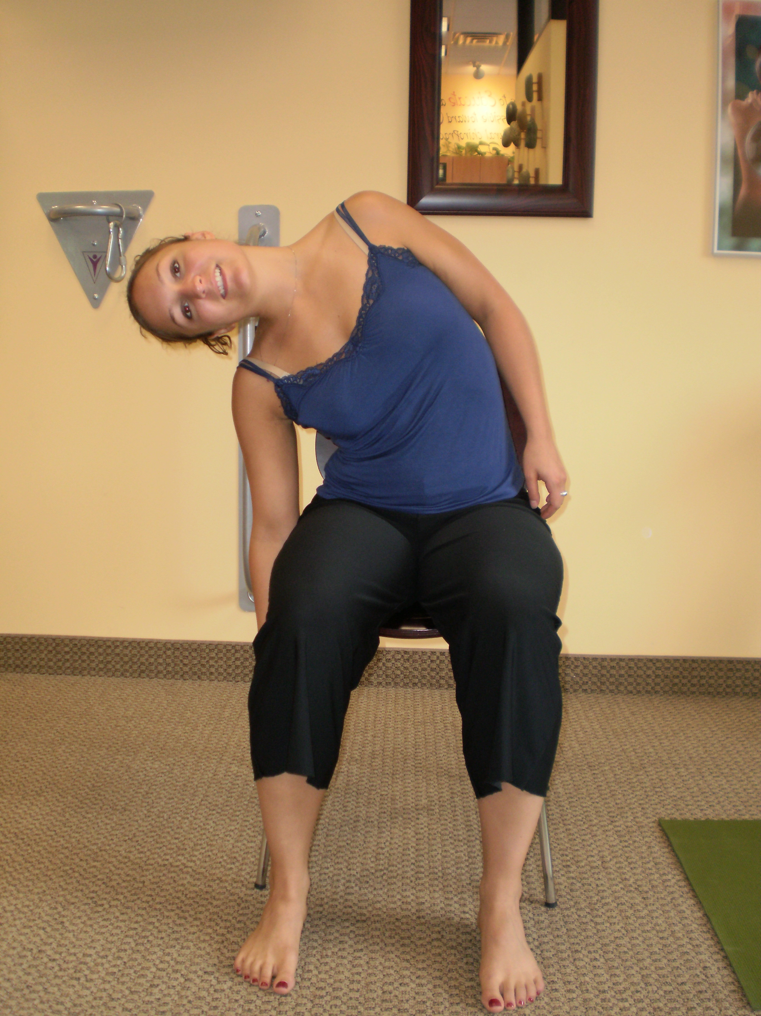
- Repeat on the right again moving each bone in your spine in a smooth, fluid motion. It’s okay to hear or feel crunching or grinding in your joints for now as they relearn how to move properly.

www.mcgovernfamilychiropractic.com 978-646-0010

