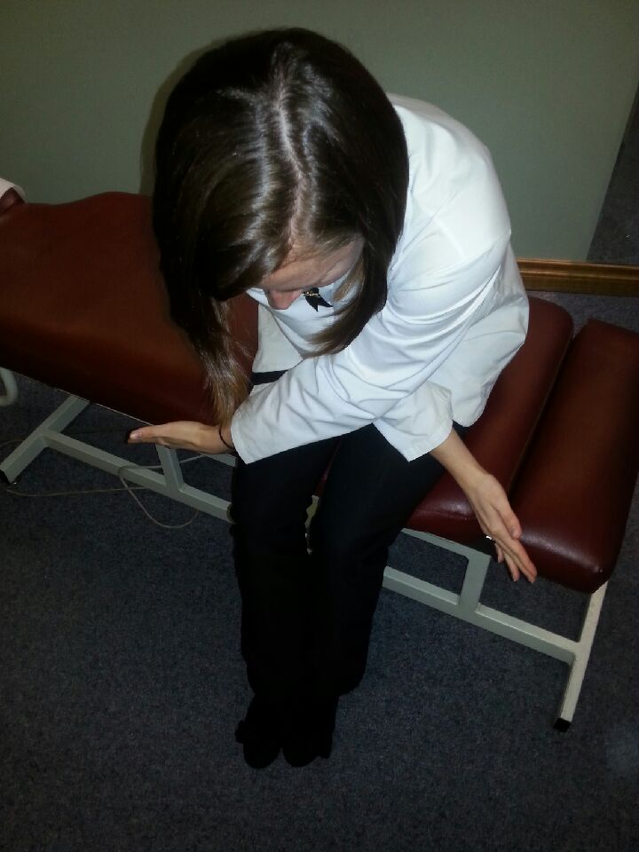
X-Seated Rhomboid Stretch
- Feet slightly apart, planted on the ground
- Knees at 90°
- Cross arms in front of the body and place them over the knees
- Maintain the curve in your low back by anteriorly tilting the pelvis and bracing the abdominals
- Increase the stretch by lifting the head to look forward and spreading the arms deeper into a “X” position
- ____x, holding each stretch for 10-15sec
- ___x / day

